|  |
| --- |
|  |
| **MITS6005 Big Data** |
| **Research Report** |
|  |
|  |
|  |

Table of Contents

Introduction 3

Objective of the Article 4

Analysis of the Article 4

Research Question 4

Main Argument 4

Traditional data warehouse and modern data warehouse 5

System design 6

Implementation and Testing 7

Research Methodology 8

Conclusion 9

References 10

Figure 1 The architecture of System by Leo Willyanto Santoso and Yulia 6

Figure 2Advance analysis of DSS academic by Leo Willyanto Santoso and Yulia 7

Figure 3Assessment of Application Usage by Leo Willyanto Santoso and Yulia 8

# Introduction

Higher educations are working upon the competitive environments that have more complex value in the marketplace. The higher education intuitions continue to produce the right solution promptly that will effectively carry out the demand factors with the bug data analysis. The information technology has worked in a very good way that will represent the ideas and has generated new solutions. Further, this paper will focus on several methods and techniques that put the data warehouse and discover the data discovery. This research report is focused on criticizing and summarizing the review paper by *Leo Willyanto Santoso and Yulia* in 2017 titled “***Date Warehouse with Big Data Technology for Higher Education”.*** The author aims to design and implement a modern data warehouse for academic information that helps in provides a support system for the decision-making process. It also focuses on the analytical decision-making dashboard and many other techniques that help in containing the change with the data-based practices in the education system. The top-level management work to identify the academic condition in their university that will propose to implement the support system for big data. It will help to acknowledge the changing variability with the help of big data analysis.

# Objective of the Article

The main objective of the article is to identify the design system that enables communication among the different datasets and platforms which includes smart phones, desktop, and web applications. It can be structured, semi-structured, and unstructured data which will identify the change in the data set in the higher education system. It also entails the changing pattern with some techniques and tools by containing the measuring ideas and associates with the linked sources [1]. Other objectives of the paper are to provide system solutions to keep the top-level management happy and know about system-generated methods that help in taking a decision-making process in their university for engaged with the change process. It also helps in identifying the proposed system that could be implemented in other universities that need a support system for big data. The analysis can be done with the help of big data analysis and try to acknowledge the change variables in the market. The higher education system can procure the ideas with more availed values that are lying to seek the changes with more effective ideas and values by keeping a good insight and contains key ideas with considering changes [1].

# Analysis of the Article

## Research Question

The problem that is identified by Leo Willyanto Santoso and Yulia in the paper is to design and implement the modern data in the warehouse for the academic information system that helps in generating the decision-making process for the universities. They also focus to identify the designed system that accommodates the Hadoop platform by containing the analytical tools and emerged to make the values with the platform analysis. The dashboard will also assume to make a definite change that can track the records of the performance and identify new preferences in the university [1].

## Main Argument

The main argument of this paper is to design the warehouse that transforms the data according to the business needs and includes the ideas by marinating the enterprise resource planning (ERP) with some extracted files that can come up to generate the change in the big data files and have availability to solve the problems. The main purpose is to improve the technology that generates the factual ideas and promote key changes in the dashboard to analyze the changes with more effective ideas and crate value to attain the change measurability in the university. Higher education seeks to avail the change by accumulating the various outcome and focus upon deliverable values in the work [1]. The Data warehouse support system is the main focus of the paper that helps in achieving the big data analysis and ensures the ideas with receiving the outcome and incorporates with the changes. The data warehouse has also worked as an important role in the action data analysis by generating some of the new ways that include transitional and modern data warehouse for generating big data with the issuance of work conditions by analyzing key changes [4].

## Traditional data warehouse and modern data warehouse

The data warehouse is the combination of two technologies and systems that helps in generating the changes with more adaptive changes and advancing in the work measures. It will maintain the historical data that could contain new analysis in the work performance and analyze the variability in the informed decisions. The data warehouse is not a product; it is an environment that cares about strategic information for other people to generate the change with more ideas and facilities in work [2]. The data warehouse also contains the collection of logical data that separates the operational database summary. The modern technique of the warehouse will advance the planning that contains dimensional modeling of the data and supports high-level queries. The Star Scheme also continues to get the effective decisions and performance which can be availed to make out better planning and effectively contains new effectual data analysis by acknowledging the change due to some variability in the market [1].

Whereas, the traditional data warehouse cannot handle a large amount of data as it is very significant in entire that could not idealize the changes with an online education system that support the sources with some other values that have been containing the changes and delivering the prospective ideas [3]. The integrated design system of Hadoop technologies will solve the problems and containing the large amount that can cope up with the changes in need to analyze the change measurement with the available data and possible outcome that can ensure the possible advantage in the work. Moreover, the traditional data cannot extract the unstructured data with definite changes that could be articulated to manage the deliverable change with significant sources and work performance. It also takes support of OLAP-based analysis that could help in define the values with the ideas and have deliverable to get the association work with some conditional outcomes [1].

## System design

The higher education system can contain effective ideas with delivering the values and engaged to seek the different measures with other work conditions. ETL is the main process in the traditional data warehouse that cannot handle unstructured data. For this purpose, the ETL has been introduced to handle several quality issues, duplicate data, inconsistent data, and garbage data that have been associates with the changed purpose by containing the derivative factors in work. The Hadoop and RDBMS also help in manage the data in a good way that represent the systematic ideas with effective values and decisions to make identified work conditions [1].

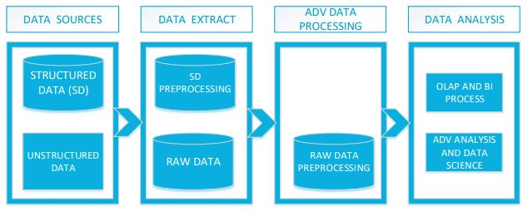

Figure 1 The architecture of System by Leo Willyanto Santoso and Yulia

The architecture of the proposed system has been availed to make the system presented in the factual ideas and formulate the structured and unstructured data that has included their systematic work and platform for seeking valuable change in the big data analysis. The unstructured data includes videos, webpage’s and other web server logos that can be represented with the new presence of the source and ideally make out the values by containing key changes and accumulate with general functions with advancing of planning and come up with key ideas [5].

The predefined work also merged to take the available sources that must be effective to meet certain factors and ideas by managing the structural factors. The contextualized data can be expressed in a better way to analyze the store and pattern of work within which it can be explored and manage the work condition for containing the activities in the data analysis. The explored data and aggregate data by using the OLAP techniques and business intelligence can help in taking out the change with the analysis of the variability in the market and have new ideas to receive the change [6]. It can be contained the measurement in work that could ideally deliver the data extraction in work.

## Implementation and Testing

The implementing and testing process in the paper will be followed by the system that will work according to analysis and system design by generating the changes and have ideally meet the criteria of work in need to engage with the work performed. The data will come from different areas that have sufficient values in the work to replace with some social media platforms like Facebook, Linked In, and Twitter. The report can be customized with the help of different measurement and functions to effectively analyses the data and have formulated with key conditional sources by generating the changing variability in the data analysis [1].

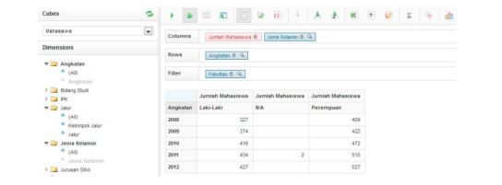

Figure 2Advance analysis of DSS academic by Leo Willyanto Santoso and Yulia

The customized data can be seen over the main measurement towards the work that could have effective utilization of the data. In higher education, the system can be generated to enforce the change with some other values and possibly carry out the ideas that have emerging insights towards the work [6]. The customized data can be trying led to seek the change with some certain ideas that need to fulfill all the work possible and helps in a measure the effective focus with analyzing the outcome at one place.

## Research Methodology

In the paper of Leo Willyanto Santoso and Yulia, the analysis has been done on the primary research. They have collected the information from the university staff with the help of a Questionnaire. The research has been covering all the top-level management, middle management, and bottom management to analyze the data warehouse and captured the ideas with their thinking process [1]. The graphic customized feature has also viable to make out several differences in the research that helps in analyzing the ideas with some generating values. The assessment can be analyzed and enhanced the changes with the key variable sources by acknowledging the changing variability and manage the work source with several availabilities in the work. The detailed assessment can also provide the possible work with some other source that can manage to know about the big data with the greater analysis of work.

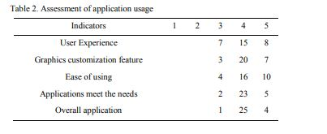

Figure 3Assessment of Application Usage by Leo Willyanto Santoso and Yulia

The above table provides the questionnaire response that helps in identify that 97% of the respondents said that the placation is good and have good analytical ideas by engaged in the function and have taken new outcomes to formulate with the key changes. It also ensures the key measurability in the system with different data analyses [1].

# Conclusion

The study that is explored by Leo Willyanto Santoso and Yulia has been taking source ideas towards the traditional data warehouse which cannot handle the big data of the education system or higher education. It has been also highlighted that the big data technology helps in reducing the difficulties and have traditional data analysis approach to make the changes with more effective source and ideas that contains new values. The education system needs to learn the ideas with the help of big data approaches to identify the key measures and have effective analysis in the work.

# References

[1]

Elsevier B.V., “Data Warehouse with Big Data Technology for Higher Education,” *Procedia Computer Science*, 2017. https://pdf.sciencedirectassets.com/280203/1-s2.0-S1877050917X00227/1-s2.0-S1877050917329022/main.pdf (Accessed Sep. 24, 2021).

[2]

M.A. Nazarenko and T.V. Khronusova, “Big data in modern higher education. Benefits and criticism,” *International Conference" Quality Management, Transport and Information Security, Information Technologies"* pp. 676-679, September. 2017, doi: 10.1109/ITMQIS.2017.8085914

[3]

Y. Li, P. Li, F. Zhu and R. Wang. “Design of higher education quality monitoring and evaluation platform based on big data,” *International Conference on Computer Science and Education.* pp. 337-342). August. 2017, doi: 10.1109/ICCSE.2017.8085513

[4]

A. Oussous, F.-Z. Benjelloun, A. Ait Lahcen, and S. Belfkih, “Big Data technologies: A survey,” *Journal of King Saud University - Computer and Information Sciences*, vol. 30, no. 4, pp. 431–448, Oct. 2018, doi: 10.1016/j.jksuci.2017.06.001.

[5]

P. Merla and Y. Liang, “Data analysis using hadoop MapReduce environment,” *2017 IEEE International Conference on Big Data (Big Data)*, Dec. 2017, doi: 10.1109/bigdata.2017.825854.

[6]

J. Wang, Y. Yang, Tian Wang, R. Simon Sherratt, and Jingyu Zhang, “Big Data Service Architecture: A Survey,” *Journal of Internet Technology*, vol. 21, no. 2, pp. 393–405, 2020, Accessed: Sep. 23, 2021. [Online]. Available: https://jit.ndhu.edu.tw/article/view/2261.